# 

Table of Contents

I. Introduction 3

II. Minimization total cost 3

1. Problem formulation 3

**a) Reducing the probability of leaving to 20% lower than current values** 3

**b) Reducing the probability of leaving to 60% lower than current values** 5

2. Solution for the IntelliAuto problem 6

**a) Reducing the probability of leaving to 20% lower than current values** 6

**b)** **Reducing the probability of leaving to 60% lower than current values** 7

III. Discussions 7

IV. Recommendations 9

1. Favorable salary 9

2. Enhance spiritual encouragement 9

3. Employee empowerment 10

Appendix 10

References 11

# **I. Introduction**

The-knowledge economy's success-and-the process of-economic-globalisation tend-to-increase organizational structure-flexibility, which-puts the-stability of the-employment-relationship under pressure. Employees-want lifelong-employability-instead-of-lifetime-employment-to deal with this-instability-(Ling-et-al. 2013).

The-IntelliAuto-company is currently-modernising-and-changing to accommodate-industry-4.0. The-internal-labour-market-oriented-system has-been severely tested by-this-process, leading to a stronger external-market-orientation, which has-had-a-significant impact on employee work attitudes-and-behaviour. The-issues-that-IntelliAuto must-now-confront in-the-current employment-environment include how to preserve employee stability, particularly-with-regard-to-core-personnel, how-to strengthen-their-organisational commitment-and-how-to-develop an organization's-competitive-edge.

In-an-effort-to-understand-and-mitigate employee-attrition-in-the-IntelliAuto, this-analysis utilizes-logistic-regression-to-determine the-top-five-of-highest-probability-of employees leaving-the-company within-the-next-10-years. The-company's-management-team-seeks to explore potential incentives that can-effectively reduce the-probability-of-employee-turnover by 20%-and-60% within-this-timeframe. Two-main-incentives are-being-considered: sending-employees-to-seminars-and-increasing-employee-salaries. Hence, in-this-report, the-primary-objective-is-to identify-the-minimum-cost incentives-schedule-together-with-providing several recommendations-for-the-organization-in-order-to-reach-its-target.

# **II. Minimization total cost**

## **1. Problem formulation**

After-using-the-logistic-regression, five-employees-with-the-highest-probability-of-leaving-the-company-in-less-than-10-years-are-identified:

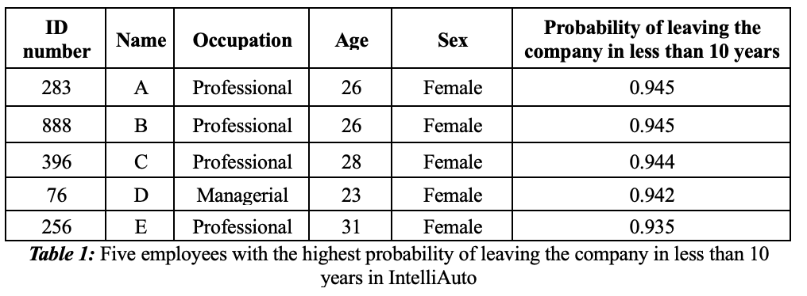

### **a) Reducing the probability of leaving to 20% lower than current values**

In-order-to-identify-the-minimum–cost-incentive-schedule, we-will-formulate-the-IntelliAuto problem-as-a-linear-program. Firstly, we-define the-decision-variables-and-the objective function for-the-problem. Let:

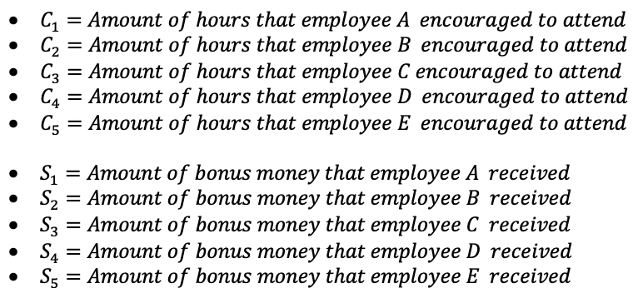

With-the-cost-of-each-hour-of-the-conference-and-the-amount-of-increased-salary-as-shown-in the-Table-2-and-Table-3. The-objective-function-that-corresponds-to-the-minimization-of-the-total-incentive-cost-can-be-written-as:

$$Min C_{1}{+ C}_{2}+C_{3}{+ 0.8C}_{4}{+ C}_{5}+S_{1}+S_{2}+S_{3}+S_{4}+S_{5}$$

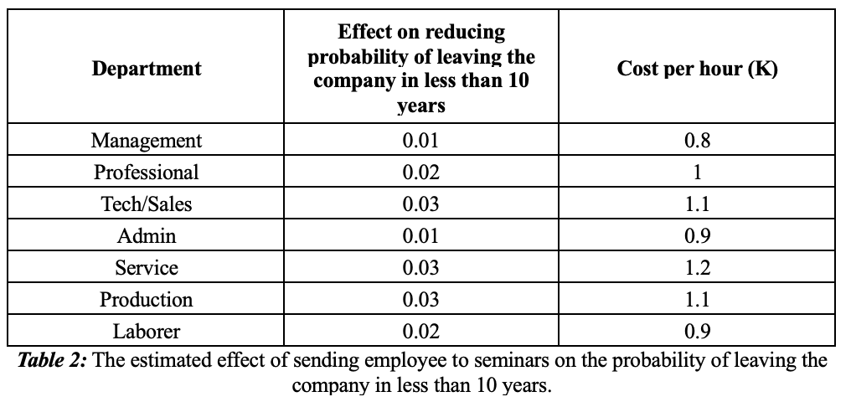

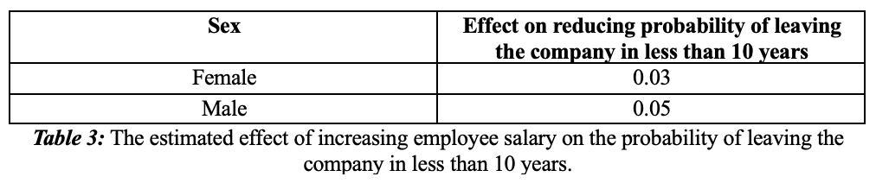

Next-consider-the-constraints-placed-on-the-IntelliAuto-problem. To-satisfy-the-limitation-of-20-hours-on-available-conferences-time, the-total-of $C_{1}, C_{2}, C_{3}, C_{4}, C_{5}$ must-be-less-than-20 hours:

$$C_{1}{+ C}_{2}+C_{3}{+ C}_{4}{+ C}_{5}≤20$$

For-the-limitation-of-$35-thousand-for-the-bonus-salary, the-overall-amount-of-bonus-salary-for-those-5-employees-should-not-be-exceed-$35-thousand:

$$S_{1}+S_{2}+S_{3}+S_{4}+S_{5} ≤35$$

Finally, since-the-aim-of-the-company-is-to-reduce-the-probability-of-leaving-the-company-in-less-than-10-years-to-20%-lower-than-current-probability-values, we-add-the-constraint:

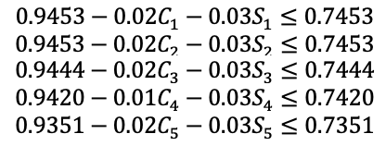

After-adding-the-nonnegative-constraints-($C_{1}{, C}_{2}, { C}_{3}{, C}_{4}{, C}_{5}, { S}_{1}, { S}_{2}, S_{3}, S_{4}, S_{5}≥0)$, we-arrive-the-following-linear-program-for-the-IntelliAuto-problem-which-aiming-to-reduce-the-probability-of-leaving-the-company-in-less-than-10-years-of-those-five-emplyees-to-20%-lower-than-currentvalues :

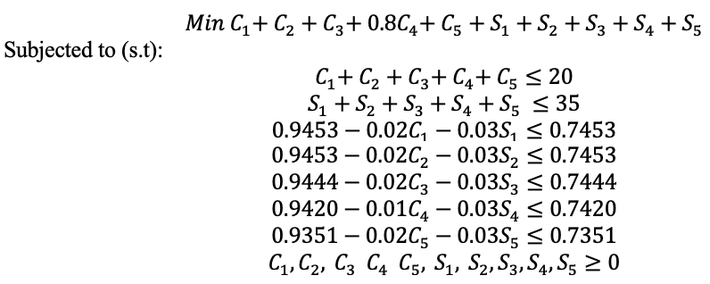

### **b) Reducing the probability of leaving to 60% lower than current values**

The problem formulation of IntelliAuto in this case is quite similar to the above scenario, except the final constraint. Hence, the linear program for the IntelliAuto problem which aiming to reduce the probability of leaving the company in less than 10 years of those five emplyees to 60% lower than current values is shown:

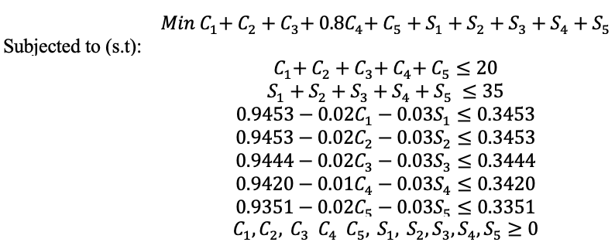

## **2. Solution for the IntelliAuto problem**

A spreadsheet model for the IntelliAuto company problem along with the Solver dialog box are shown in Figure 1. The complete linear programing model for the IntelliAuto problem in Excel Solver is contained in the IntelliModel. We use the SUMPRODUCT function to calculate total cost in cell K6 and also to calculate total amount of money spent in cell K14.

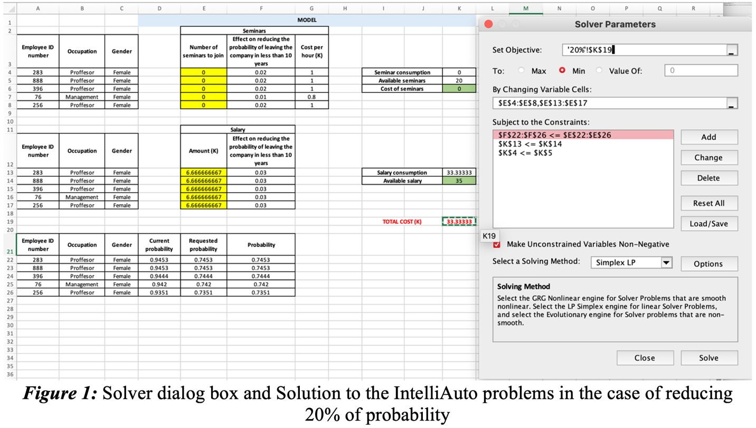

### **a) Reducing the probability of leaving to 20% lower than current values**

The optimal solution for the first scenario, which is shown in the spreadsheet and in the Answer Report in Figure 2, is to spend almost all of the company's $35 thousand budget on a pay raise for these five employees. Specifically, according to Solver's results, in order to reduce the probability of leaving the company in less than 10 years of those five employees to 20% lower than current value, the company should spend about $33.33 thousand (an increase of about $6.67 thousand for each employee out of five) for a raise and should not spend any money on sending employees to upskilling seminars.

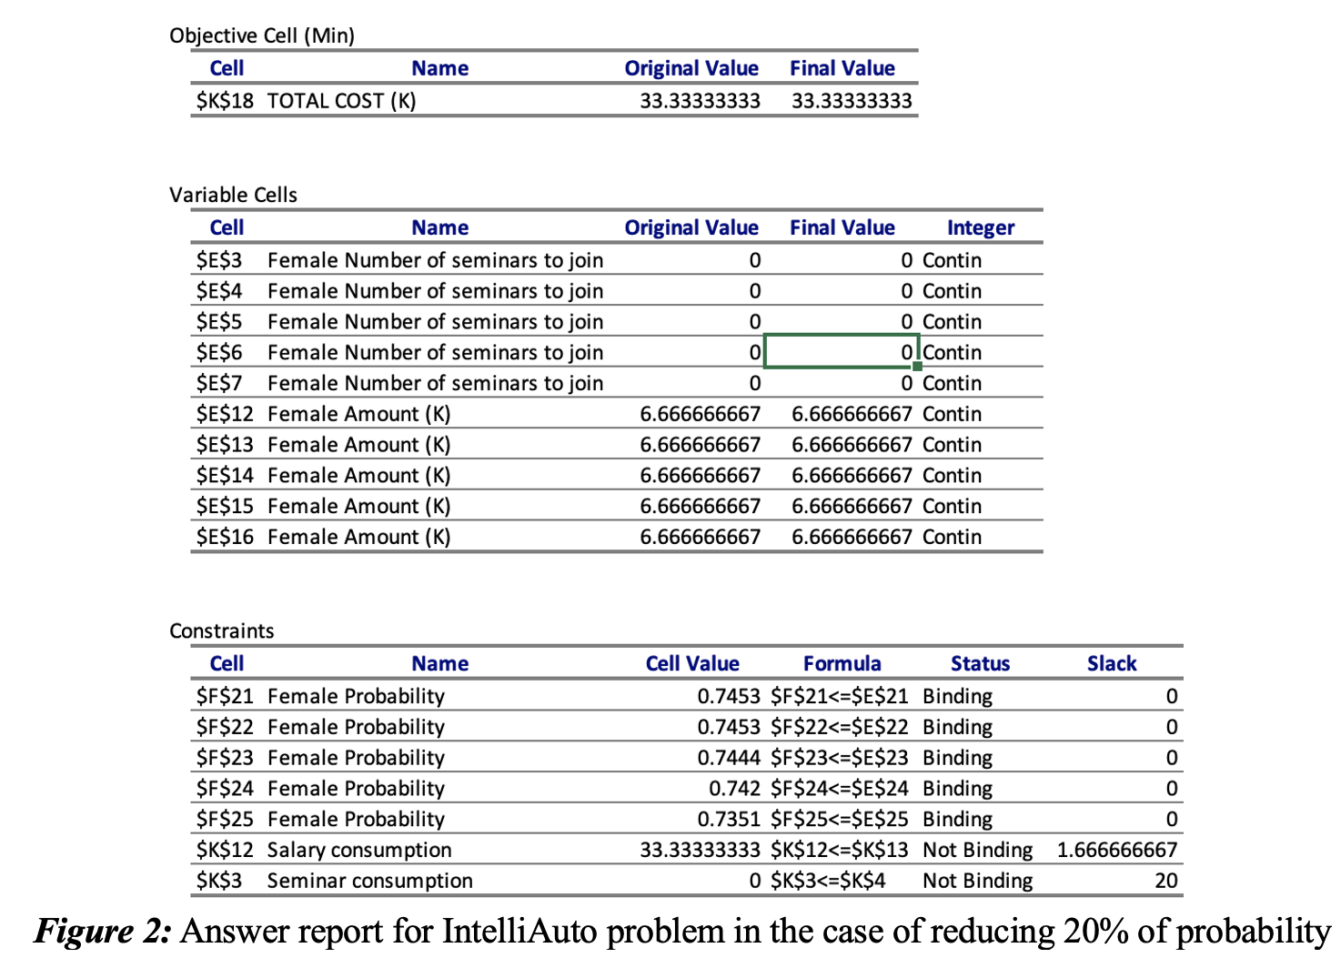

### **b)** **Reducing the probability of leaving to 60% lower than current values**

Contrary-to-the-results-of-the-above-scenario,-the-Solver-solution-for-this-case-is-appeared-to-be-infeasible-meaning-that-no-solution-to-the-linear-programming-problem-satisfies-all-the-constraints,-including-the-nonnegativity-conditions.-Specifically,-by-using-such-incentives-of-both-seminars-and-salary,-it-is-impossible-to-reduce-the-current-probability-of-leaving-the-company-less-than-10-years-of-those-five-employees-by-60%.

# **III. Discussions[1]**

According to the Sensitivity report in the Figure 3, since the last two constraints are nonbiding constraint, the shadow prices for then are equals to 0. This means even though the company increased its budget for corporate rewards by 1 or more thousands of dollars, there would be no change in our optimal objective function value which is the minimum–cost incentives schedule.

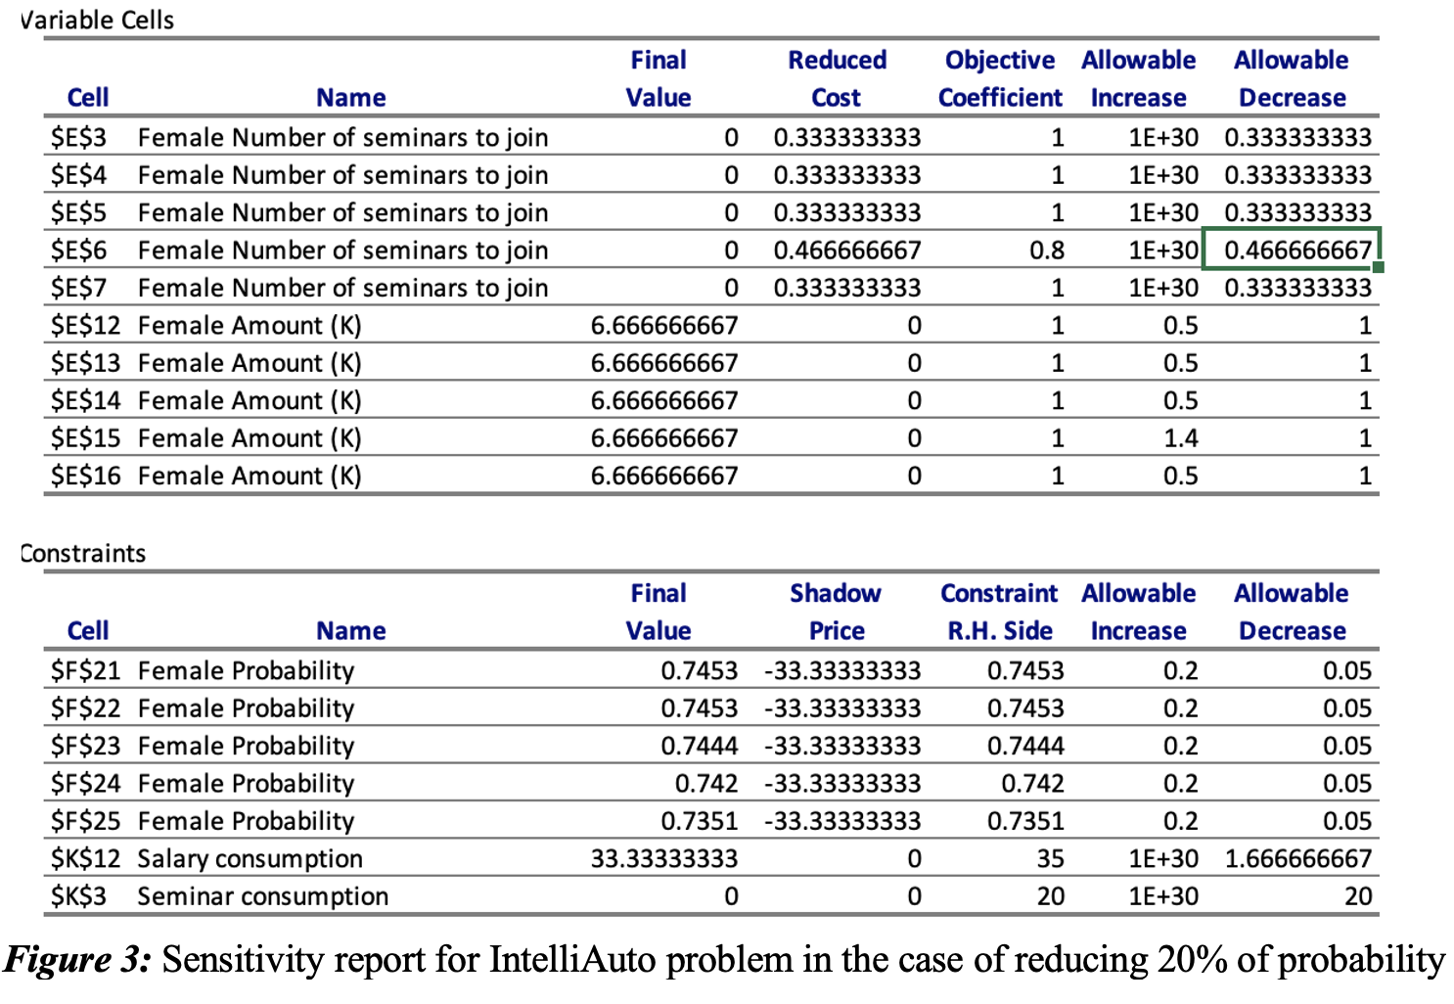

Furthermore, the Allowable said of the probability in the Constraint section indicated by 0.05 is also noteworthy. This data shows us that if a business decides to reduce the requested probability of leaving for each employee by 0.05, it will have to spend an extra $-\left(-33.3\right)×0.05≈\$1.7 thousand$ in its budget per employee pellets. Thus,-with-5-employees,-IntelliAuto-will-have-to-spend-about-8,5-thousand-in-total-if-it-wants-to-reduce-the-possibility-of-these-employees-leaving-the-company-by-5%,-which-exceeds-the-initial-spending-budget-for-increasing-the-number-of-employees-salary-($35-thousand).-Therefore,-with-this-calculation-together-with-the-condition-of-the-Allowable-decrease,-the-company-can-further-set-the-goal-of-further-reducing-the-probability-to-more-1.3%-(21.3%-in-total)-in-order-to-both-increase-the-likelihood-of-staying-in-the-job-of-the-employee's-company-while-still-ensuring-the-company's-limited-budget-for-this-bonus-item.However, our team does not recommend the company to use this method since its efficiency is quite low (only increase by 1.3%) while the company has to spend $33.3-\left(-33.3\right)×0.02≈35 thousands$. Thus, we recommend that the company save this excess of approximately $1.67 thousands (slack = 1.67) for other effective incentives (will be discussed below) of the company.

Additionally, based-on-our solution-above, it is not neccessary to send employees to different seminars in order to reduce their probability of leaving by 20%.The Allowable decreases and the Allowable increases in the-Variable-cells in-our Sensitivity-report also supports this (Figure 3). Specifically, for-example-of the first-variable, the value $1E+3$ in the report is essentially infiity. So-long-as-the-cost of each hour of the seminar is greater than or equal to $1-0.33=0.67$ and less than positive infinity, the current solution remains optimal. In other words, even if the cost per hour of the seminar is almost free ($0.67 thousand), it is still advisable not to send employees to these seminars to increase employee skills and morals, which indicates the unimportant and less effective of those seminars in reducing the probability of leaving the company in less than 10 years by 20% for those five employees. This-is-also-supported-by-previous-literature-since-some-of-them-have-studied-the-relationship-between-training-and-organizational-commitment-and-considered-their-relationship-cannot-be-lumped-together. Specifically,-on-the-job-training,-company-courses,-and-tuition-reimbursement-are-specifically-linked-to-affective-commitment,-according-to-research-by-Benson-(2006). However, when-employees-receive-a-diploma-or-certificate-that-is-widely-recognised-by-markets,-they-will-leave,-unless-they-believe-they-will-be-promoted.-In-other-words,-training-has-a-double-edged-sword-since-it-will-raise-employee-employability-and-decrease-turnover-intention-from-the-perspective-of-planned-profit-maximisation.-As-a-result,-businesses-will-face-the-danger-of-"making-wedding-gowns-for-others"-when-investing-in-human-capital-(Ling-et-al.-2013). This-is-because-improving-general-talent-gives-employees-additional-options.-This-is-completely-consistent-with-our-case-since-all-these-5-employees-are-in-the-positions-of-Profesors-and-Management,-which-already-requires-high-education-experience,-thus-providing-more-training-courses-and-improving-skills-and-capabilities-may-be-less-attractive-to-them-and-reduce-the-level-of-commitment-to-the-company.

Finally,-the-solution-also-suggests-that-reducing-the-probability-of-leaving-the-company-by-60%-of-the-company-given-the-resources-available-of-20-hours-for-seminars-and-$35-thousand-for-salary-incentive-is-unrealistic-and-unattainable.-Thus,-in-order-to-make-this-a-reality,-the-company-is-forced-to-increase-its-budget,-which-might-be-expensive-and-we-are-not-highly-recommend-this-solution.

# **IV. Recommendations**

## **1. Favorable salary**

Shaw-et-al.-(1998)-defined-pay-as-a-payment-made-in-return-for-services-provided-inside-an-organisation.-It-has-been-important-in-keeping-and-rewarding-top-notch-human-resources.-To-be-more-specific,-a-reduced-income-is-one-of-the-major-causes-of-employee-turnover.-Employees-have-a-tendency-to-leave-an-organisation-when-they-obtain-a-reduced-income-and-insufficient-financial-benefits-(Lavob-1997).-It-is-sometimes-said-that-faulty-pay-scale-procedures-are-mostly-to-blame-for-employee-turnover-due-to-work-discontent.-A-new-employee-may-wonder-why-the-person-sitting-next-to-him-receives-a-high-wage-for-what-is-thought-to-be-a-similar-work-(Ghosh-et-al.-2013),-which-is-an-excellent-example-of-this.-According-to-a-widely-held-belief,-high-compensation-may-play-a-significant-role-in-determining-work-happiness,-which-in-turn-can-increase-organisational-productivity.-Therefore,-IntelliAuto-should-keep-implementing-the-pay-bonus-for-those-five-workers-in-order-to-lower-their-likelihood-of-leaving-the-firm-in-less-than-10-years-by-20%-based-on-our-research-and-our-findings.-This-likelihood-can-be-further-decreased-if-the-business-moves-seminar-costs-from-employee-travel-to-compensation-increases-since,-as-was-previously-said,-seminars-are-deemed-unproductive-in-our-situation.-

## **2. Enhance spiritual encouragement**

Employees, particularly those with higher education levels, are always seeking for chances to demonstrate their worth, excel in their existing roles, and climb the corporate ladder (Prince 2005). The main causes of high labour turnover in an organisation are thus insufficient personnel policies, subpar supervision techniques, subpar grievance procedures, or a lack of motivation (Curtis et al. 2008). All of these signs point to a lack of proper management practises and policies on personnel matters, which causes the employees to be managed ineffectively, the organization's promotion policy to be improperly communicated to the employees, the absence of grievance procedures within the organisation, and the employees, especially the highly skilled ones, to decide to leave.

To-retain-personnel-and-establish-a-competitive-position-for-the-business-in-the-age-of-digital-transformation,-IntelliAuto-should-focus-on-appreciating-the-contributions-and-performance-of-its-staff-and-improving-the-firm's-incentive-plan.-4.0.-Provide-exceptional-employees-with-several-options-for-progression-inside-the-company-(Prince-2005).-Linz-et-al.-(2015)-found-that-recognition-from-supervisors,-coworkers,-customers,-and-team-members-increases-loyalty.-In*-*the*-*research,-Pergamit*-*and*-*Veum*-*(1989)*-*discovered-a*-*strong*-*and-favourable*-*relationship*-*between*-*promotions*-*and*-*work*-*satisfaction,-which*-*in*-*turn-aids*-*in-staff*--*retention.-According-to-Silbert-(2005),-incentives-are-important-because-they-have-a-long-lasting-effect-on-workers,-which-in-turn-makes-them-feel-valued-by-the-organisation.-Additionally,-work-flexibility,-along-with-exciting-career-and-life-opportunities,-is-a-vital-incentive-for-all-employees-and-enhances-their-commitment-to-the-company,-according-to-Curtis-et-al.-(2008).

**3. Employee empowerment**

Retaining knowledgeable and talented employees is crucial for any organisation in this cutthroat industry. An organization's reputation and image may be harmed by a high turnover rate. Employee replacement is difficult and expensive since, in the event that an experienced employee leaves, the company must educate a new hire. In order to prevent employee turnover and work fatigue, human resources strategies should emphasise increasing individual autonomy (Salman, Iqbal, and Chandran 2010). According to Hong et al. (2012), HR policies encourage skilled labour, which has a strategic role in employee retention.

Because they are given greater control in the decision-making process, empowered workers specifically tend to be more self-assured and want to deliver their best to the company (Naeem and Saif 2010). Employees may feel obligated to remain with the company as a result of employee empowerment. Because they feel like a part of the organisation, the employees will often continue working there despite pressure from coworkers who want to quit (Hong et al. 2012). In essence, employee job satisfaction determines if they have any plans to stay or quit the company. A person who is more satisfied with their employment tends to be more dedicated to the company and the will be more inclined to stick with the company (Hong et al. 2012).

# **Appendix**

**Appendix 1: Female employees at IntelliAuto tend not to stay with the company for a long time**

All five of the employees at IntelliAuto who have been with the company for less than ten years, as shown in Table 1, are women, which may indicate underlying issues within the company, such as gender discrimination, unequal opportunities for professional advancement, or a lack of support for work-life balance (Kang and Kaplan 2019). According to Gutek, Cohen, and Konrad (1990), organisational practises, policies, and culture all exhibit systemic prejudice against women. According to Rosen and Korabik (1991), this might lead to a negative organisational culture, poorer worker morale, and decreased employee engagement. Additionally, according to a lot of literature, women who quit organisations can not only be seeking for pay that are comparable to what they were earning before, but also for a better overall employment package, including whether the new workplace is more female-friendly and less political (Stroh and Reilly 1997). Stroh and Reilly (1997) contend that redefinition rather than retreat is the solution to the issue. Executive women emerge from this period making big midcourse modifications in significant numbers. Therefore, firms seeking to recruit and retain female managers must take into account issues including the degree of organisational politics and the availability of career opportunities.

As a result, the firm has to develop family-friendly policies that promote work-life balance, such as maternity leave, childcare assistance, and flexible working hours. These laws may lessen some of the difficulties that women may experience in juggling their obligations to their families and their careers.

# **References**

Benson GS (2006) ‘Employee development, commitment and intention to turnover: a test of ‘employability’ policies in action’, *Human Resource Management Journal*, <https://doi.org/10.1111/j.1748-8583.2006.00011.x>.

Curtis CR, Upchurch RS and Severt DE (2008) ‘Employee Motivation and Organizational Commitment: A Comparison of Tipped and Nontipped Restaurant Employees’, *International Journal of Hospitality and Tourism Administration*, 10(3): 253 – 269, <https://doi.org/10.1080/15256480903088469>.

Ghosh P, Satyawadi R, Joshi JP and Shadman M (2013) ‘Who stays with you? Factors predicting employees' intention to stay’, *International Journal of Organization Analysis*, 21(3): 288 – 312, <https://doi.org/10.1108/IJOA-Sep-2011-0511>.

Gutek BA, Cohen AG and Konrad AM (2017) ‘Predicting Social-Sexual Behavior At Work: A Contact Hypothesis’, *Academy of Management Journal*, 33(3), https://doi.org/10.5465/256581.

Huselid MA, Beatty RW and Becker B (2006) ‘A Players or A Positions? The strategic logic of workforce management’, *Harvard Business Review*, 83(12):110 – 117.

Kang SK and Kaplan PS (2019) ‘Working toward gender diversity and inclusion in medicine: myths and solutions’, *The Lancet*, 393(10 – 171): 579 – 586, https://doi.org/10.1016/S0140- 6736(18)33138-6.

Labov B (1997) ‘Inspiring employees the easy way’, *Incentive*, 171(10): 114 – 118.

Ling L, Quing T and Shen P (2014) ‘Can training promote employee organizational commitment? The effect of employability and expectation value’, *Nankai Business Review International*, 5(2): 162 – 186, <https://doi.org/10.1108/NBRI-09-2013-0034>.

Linz S, Good LK and Busch M (2015) ‘Promoting worker loyalty: an empirical analysis’, *International Journal of Manpower*, 36(2): 169 – 191, https://doi.org/10.1108/IJM-06-2013- 0129.

Naeem H and Saif MI (2010) ‘Employee empowerment and customer satisfaction: Empirical evidence from the banking sector of Pakistan’, *African Journal of Business Management*, 4(10): 2028 – 2031.

Pergamit MR and Veum JR (1999) ‘What is a Promotion?’, *ILR Review*, 52(4): 581 - 601, https://doi.org/10.1177/001979399905200405.

Prince JB (2005) ‘Career‐focused employee transfer processes’, *Career Development International*, 10(4): 293 – 309, https://doi.org/10.1108/13620430510609136.

Rosin HM and Korabik K (1991) ‘Workplace variables, affective responses, and intention to leave among women managers’, *Journal of Occupational Psychology*, 64(4): 317 – 330, https://doi.org/10.1111/j.2044-8325.1991.tb00563.x.

Shaw K (2005) ‘An engagement strategy process for communicators’, *Strategic Communication Management*, 9(3): 26 – 29.

Silbert LT (2005) ‘The Effect of Tangible Rewards on Perceived Organizational Support’. Silverstein M (2008) ‘Meeting the challenges of an aging workforce’, *American Journal of Industrial Medicine*, https://doi.org/10.1002/ajim.20569.

Stroh LK and Reilly AH (1997) ‘Rekindling Organizational Loyalty: The Role of Career Mobility’, *Journal of Career Development*, 24(1), https://doi.org/10.1177/089484539702400103.

Zheng L, Ramendran C, Mohamed RKMH and Kadiresan V (2012) *An Effectiveness of Human Resource Management Practices on Employee. Retention in Institute of Higher learning: -A Regression Analysis*, ResearchGate website, accessed 6 June 2023. <https://www.researchgate.net/profile/Charles-Ramendran/publication/267725979_An_Effectiveness_of_Human_Resource_Management_Practices_on_Employee_Retention_in_Institute_of_Higher_learning_-A_Regression_Analysis/links/54d0dacf0cf298d6566937a0/An-Effectiveness-of-Human-Resource-Management-Practices-on-Employee-Retention-in-Institute-of-Higher-learning-A-Regression-Analysis.pdf>.

1. Other discussion together with recommendation is explained in the Appendix 1 since it is not related to the Sensitivity report of the IntelliAuto problem.